HardwareX article template Version 2 (June 2021)

Before you complete this template, a few important points to note:

- Unsure whether your designs would make a suitable hardware article? Visit our webpage Everything you need to know about HardwareX.
- The format of a hardware article is very different to a traditional research article. To help you write yours, we have created this template. We will only consider hardware articles submitted using this template.
- HardwareX is dedicated to the communication of advances in open source scientific infrastructure. By submitting to the journal, you are confirming that all the information necessary to reproduce your design/hardware is communicated in full and is accessible for use under an open source license.
- It is important that the designs referred to in your HardwareX article are publicly available. You’ll find information on our hardware sharing criteria in the template. Not sure how to prepare your hardware for sharing? The Open Source Hardware Association has some best practice tips.
- Please consult the HardwareX Guide for Authors when preparing your manuscript; it highlights mandatory requirements and is packed with useful advice. We have also developed a step-by-step video guide to help you complete this template accurately and increase your chances of acceptance.
Still got questions?
- Visit our Everything you need to know about HardwareX webpage or email us at hardwareX@elsevier.com

Now you are ready to fill in the template below. As you complete each section, please carefully read the associated instructions. All sections are mandatory.
Once you have completed the template, delete this line and everything above it before submitting your article. In addition, please delete the instructions in the template (the text written in italics).
- - - - - - - - - - - - - - - - - - - - - - - - - - - - - - - - - - - - - - - - - - - - - - - - - - - - - - - - - - - - - - - -

Article title
A General Purpose Alarm Device (GPAD)

Authors
Robert L. Read*, Lawrence Kincheloe, Forrest Lee Erickson

Affiliations
Robert L. Read Lawrence Kincheloe Forrest Lee Erickson
Public Invention Public Invention Public Invention
1709 Norris Dr. 3217 Brush Creek Road 1709 Norris Dr.
Austin, TX, 78704 Oklahoma City, OK 73120 Austin, TX, 78704

Corresponding author’s email address and Twitter handle
read.robert@pubinv.org
twitter: @robertleeread

Abstract
Max. 200 words. Remember that the abstract is what readers see first in electronic abstracting & indexing services - make it brief, specific, interesting and easy to understand. If a research article refers to your hardware, cite that research article here.

The General Purpose Alarm Device (GPAD) shines lights and makes loud noises to draw the attention of a human being to a problem. It has a programmable 80 character display to provide textual info. A mute button toggles the sound on and off. Fundamentally it is designed to act as a peripheral to a controlling computer or microcontroller. The controller may communicate over a USB (COM) connection or through a 5V SPI connection via an RJ12 cable. The GPAD is intended to be as general as possible, so that it can be used to alarm many engineering, scientific, and hobby machines, instruments, and situations. The original driving using case is to provide medical alarm capability to the PolyVent open-source mechanical medical ventilator. The GPAD supports 5 alarm levels above “silent” of increasing urgency in terms of light, rhythm, and frequency. It is based on the Arduino Uno Atmega328 design and potentially extensible the same way an Uno is, through headers and shields. It includes the printed wiring assembly, firmware for the GPAD peripheral, a simple documented API and a 3D printable enclosure. The repo includes instructions for using a second GPAD as a controller.

Keywords
alarms, arduino, UNO, SPI, medical alarms, monitoring

Specifications table
Please replace the italicized instructions in the right column of the table with the relevant information about your hardware.

Hardware name | General Purpose Alarm Device (GPAD) v2.0
Subject area | General
Hardware type | Other: general alarms for digitally detectable alert conditions
Closest commercial analog | No know commercial analog is available.
Open source license | CERN Open Hardware Licence Version 2 - Strongly Reciprocal
Cost of hardware | $100.00
Source file repository | If you’ve uploaded your source files to an approved repository (OSF, Mendeley Data or Zenodo) write the DOI URL here.  For example: http://doi.org/10.17605/OSF.IO/WGK7Q
OSHWA certification UID  (OPTIONAL) | US002352

- Hardware in context
Write a short description of the hardware and provide context, i.e., describe similar open hardware and proprietary equipment in the field.

We are not aware of anything that has the programmable features of the GPAD. Electronic component firms such as Mouser and Digikey sell buzzers, sirens, and loudspeakers which can make noise; they sell lights that can represent an alarm condition; they sell proprietary alarm devices that are tired to special purposes (such as a smoke alarm), but we know of know digitally controllable system that combines these features. One device we know of is the Adafruit Towerlight (Product ID: 2993), an example of a “stacklight”, but it does not seem to have a digital interface, and has no text output capability, and no abstract API. Mucco (https://muccosignal.com/product/warning-horns-with-16-tons/) makes a complete line of line of integrated warning horns and stack lights, but they appear to have no digital interface, no text, and no alarm levels; they are simply on or off. Although we believe a GPAD is a widely usable device, its use is of course confined to manufacturers, makers, or engineers who are capable of programming it, which may preclude the market volume associated with consumer devices.

The digital controllers for 3D printers can often make a beep, and have a digital display, which is sometimes backlit. This has some of the features of the GPAD, but is not as bright or as loud, nor programmed for this purpose as conveniently. A cheap example is the HiLetGo 3-01-0889.

- Hardware description
Describe your hardware, highlighting the customization rather than the steps involved in the procedure. Explain how it differs from other hardware and the advantages it offers over pre-existing methods. For example, how does this hardware compare to other hardware in terms of cost or ease of use, or how can it be used to develop further designs in a particular area?

We have designed a printed wiring assembly and an enclosure. The enclosure is approximately 160mm x 110mm x 50mm (6”x4.25”x1.75”) The assembly weights 232 grams (exclusive of any power supply).
The device has a 20x4 character display (English characters), five bright white programmable LEDs, a programmable buzzer, a “Mute” button which silences the buzzer and a non programmable power indicator LED. The enclosure hangs by (for example) tie wraps from a rail for vertical display or can rest on a horizontal surface. Typical signal connection is by an RJ12 data cable. Power is by an external wall supply with a 2.1mm center conductor power jack at 9-12V at <1000 mA.

The GPAD integrates several features hobbyist find useful in one one device. Although you can purchase 20x4 displays with parallel or I2C interfaces it is the integration in one PCB and enclosure of all of the features which our device adds to make this tethered device integrate into a system easily.

The GPAD Hardware Features:
- Five Bright LEDs,
- A buzzer to indicate urgent attention required,
- A button (to mute that buzzer) for minimum user feedback,
- A 20x4 character display to provide detailed information to the user.
- Enclosure which can be vertically mounted by hanging for example with wire ties.

Add 3-5 bullet points which broadly explain to other researchers - inside or outside of the original user community - how the hardware could help them, with either standard or novel laboratory tasks.

Scientific experiments and laboratory equipment often monitor something over time whose condition can reach a state that requires human attention. The GPAD can thus be useful in the field or laboratory for:
- Alerting to conditions which may ruin the experiment if not corrected,
- Alerting to the very conditions sought by the experimenter and therefore demanding attention.
- Indicating potential failure of the equipment or the need for maintenance, such as low battery charge, over-temperature, over-pressure, etc.
The GPAD is design to be loosely integrated with new devices. At the cost of a separate enclosure, but at the saving of not duplicating alarm design, a researcher may integrate the GPAD into their own equipment.

Design files
Your design files should be editable - see OSHWA’s open source definition of ‘Documentation’ for further details. You must then either:
- Upload your design files to one of the three approved online repositories - Mendeley Data (instructions), the Open Science Framework (instructions) or Zenodo (instructions). We recommend this option as the repositories support versioning of files.
- Upload your design files as supplementary materials (e.g., CAD files, videos…) to Hardware X’sOpen Hardware Repository online editorial system when you submit your manuscript.
- Include your design files in the body of the manuscript (e.g., as figures).

CAD files: You are encouraged to use free and open source software packages for creating the files. For CAD files, OpenSCAD, FreeCAD, or Blender are encouraged, but, if these are not available, we accept source files from proprietary CAD packages, such as Autocad or Solidworks, and other drawing packages.

3D printing. Supplementary files that facilitate digital replication of the devices are encouraged; for example, STL files for 3D printing components. We recommend uploading CAD files to the NIH 3D Print Exchange as Custom Labware and then entering the link here.

Electronics: PCB layouts and other electronics design files can be uploaded to the or other repositories or as supplementary materials.

Software and firmware: All software files used in the design and operation of the hardware should be included in the repository. Provide a description of the software and firmware and use extensive comments in the code.

- Design files summary
Complete a separate row for each design file associated with your hardware (including the primary design files). Any empty rows should be deleted.

Design file name | File type | Open source license | Location of the file
For example: Design file 1 | e.g., CAD files, figures, videos | All designs must be submitted under an open hardware license. Enter the corresponding open source license for the file. | Either enter the URL for the repository or the sentence: "Available with the article".
Firmware | A folder with source files. A README.md there describes the various source files | Firmware: Affero GPL 3.0 | https://github.com/PubInv/general-purpose-alarm-device/tree/main/Firmware
Simulation | Wokwi, simulations for Factory Test and other development efforts. | Firmware: Affero GPL 3.0 | https://github.com/PubInv/general-purpose-alarm-device/tree/main/simulation
Hardware | Folder holding a README describing the subfolders to follow. | CERN Open Hardware Licence Version 2 - Strongly Reciprocal | https://github.com/PubInv/general-purpose-alarm-device/tree/main/Hardware
GeneralPurposeAlarmDevicePCB | KiCad schematic and PCB files | CERN Open Hardware Licence Version 2 - Strongly Reciprocal | https://github.com/PubInv/general-purpose-alarm-device/tree/main/Hardware/GeneralPurposeAlarmDevicePCB
Enclosure | OpenSCAD and FreeCAD source files, STL and STEP files for the enclosure | CERN Open Hardware Licence Version 2 - Strongly Reciprocal | https://github.com/PubInv/general-purpose-alarm-device/tree/main/Hardware/Enclosure
Manufacturing | Bill of materials, Gerber files and description records of parts ordered for the builds. | CERN Open Hardware Licence Version 2 - Strongly Reciprocal | https://github.com/PubInv/general-purpose-alarm-device/tree/main/Hardware/Manufacturing
Manufacturing and Unit Test Documentation | Assembly instructions and notes | CERN Open Hardware Licence Version 2 - Strongly Reciprocal | https://github.com/PubInv/general-purpose-alarm-device/blob/main/Hardware/Documentation/ManufacturingUnitTestTroubleshootingRev2.md

For each design file listed in the summary table above, include a short description of the file below (just one or two sentences per design file).

Bill of materials
If your bill of materials is long or complex, you can upload the details in an editable spreadsheet, e.g., ODS file type, Excel spreadsheet or PDF file, to an open access online location, such as the Open Science Framework repository. Include the link here. Alternatively, the bill of materials can be submitted alongside your manuscript as supplementary material.

The spread sheet used to receive the KiCad generated BOM/PARTS LIST and to transform it into the files necessary for ordering PCB assemblies from JLCPCB is found at:
https://github.com/PubInv/general-purpose-alarm-device/blob/main/Hardware/GeneralPurposeAlarmDevicePCB/GPAD_V2_BOM.xls

Instructions are built into the spreadsheet for its use.
JLCPCB build the raw PCB and did SMT assembly and some through hole assembly. The balance of the through hole assembly was done by Public Invention volunteers.

- Bill of materials summary
Complete a separate row for each component of your hardware – all components associated with a cost should be listed and any empty rows should be deleted.

Designator | Component | Number | Cost per unit -currency | Total cost -  currency | Source of materials | Material type
If possible, use the same designator here as you use in the associated design file. If that’s not possible, you will need to explain the relationship between the two. | Name of Component 1 | Number of units | Cost per unit and the currency used | Total cost and the currency used | If possible, include a direct link to a webpage where the component can be purchased | Select from:  -Metal  -Semi-conductor  -Ceramic  -Polymer  -Biomaterial  -Organic  -Inorganic  -Composite  -Nanomaterial  -Semiconductor  -Non-specific  -Other
Enclosure LED Standoff | U_Box_V105_GPAD_LED_Standoff_single.stl | 6 | $1.01 |  | Fabricated by JLCPCB | 321PA-F NYLON
Enclosure Frontpanel | U_Box_V105_General_Alarm_Device_FrontPanel.stl | 1 | $3.05 |  | Fabricated by JLCPCB | 321PA-F NYLON
Enclosure Top | U_Box_V105_General_Alarm_Device_Top.stl | 1 | $12.4840 |  | Fabricated by JLCPCB | 321PA-F NYLON
Enclosure Bottom | U_Box_V105_General_Alarm_Device_bottom.stl | 1 | $13.00 |  | Fabricated by JLCPCB | 321PA-F NYLON
Enclosure Button | U_Box_V104_General_Alarm_Device_button.stl | 1 | $1.00 |  | Fabricated by JLCPCB | 321PA-F NYLON
Enclosure Backpanel | U_Box_V105_General_Alarm_Device_Backpanel.stl | 1 NOTE use of this is exclusive of the BackPanel Hanging Compound | $3.3480 |  | Fabricated by JLCPCB | 321PA-F NYLON
Enclosure BackPanel_Hanging | BackPanel_Hanging-CompoundV2.stl | 1 NOTE use of this is exclusive of the BackPanel | $5.90 |  | Fabricated by JLCPCB | 321PA-F NYLON
Enclosure Screws PCB mounting | Choose to fit the enclosure as fabricated | 5 |  |  | Used #6 sheet metal screws 3/8” long
Enclosure Screws, | Choose to fit the enclosure as fabricated | 4
PCB Assembly exclusive of through hole components | BOM_JLCPCB_20230228Modified.xls | 1 | $13.8674 |  | Fabricated by JLCPCB | GeneralPurposeAlarmDevicePCB-Placement20230228Modified.xls
U302 | LCD Display | 1 | 4.99 |  | https://www.aliexpress.com/item/3256803213374992.html
Nylon spacers | Spacer_0.0182x0.125 inch | 4 | $0.13 |  | McMasterCarr | 94639a702
Screw | 4-40x 3/8” | 4 | $0.12 |  | Digikey | 36-9901-ND
Nut | Nut_4-40_3/16 | 4 | $0.10 |  | Digikey | 36-4694-ND
S101 | SWITCH_TACTILE_SPST-NO_0.05A_24V | 1 | $0.13 |  | Digikey | 450-1804-ND
S601 | SWITCH_TACTILE_12mmx12mm_SPST-NO_0.05A_24V | 1 | $0.55 |  | Digikey | SW414-ND
LED White | LED_T1.75_CLEAR_WHITE | 6 | $0.65 |  | Digikey | 160-1772-ND
LED Red | LED_T1.75_CLEAR_RED | 1 | $0.36 |  | Digikey | 160-1682-ND
RV301 | POT 0.375 10K | 1 | $1.61 |  | Digikey | 3386P-103LF-ND
9-12V wall power supply | Example Jameco.com 9V 200mA | 1 | $6.95 |  | Jameco.com | 100845

You can use this space for any additional descriptions of the materials used.
The printed wiring assemblies were ordered from JLCPCB using two files:
- https://github.com/PubInv/general-purpose-alarm-device/blob/main/Hardware/Manufacturing/BOM_JLCPCB_20230228Modified.xls
- https://github.com/PubInv/general-purpose-alarm-device/blob/main/Hardware/Manufacturing/GeneralPurposeAlarmDevicePCB-Placement20230228Modified.xls

- Build instructions

Detailed instructions for the balance of manufacturing on the assemblies received from JLCPCB is in a mark down document, “Manufacturing and Unit Test Documentation, PCB Version 2.0, 20230228” found at:
https://github.com/PubInv/general-purpose-alarm-device/blob/main/Hardware/Documentation/ManufacturingUnitTestTroubleshootingRev2.md
The time to build assemblies was capture in a Github Issue.
See Github Issue #229: The labor to assemble the printed circuit assembly is approximately 40 minutes per unit.
Provide detailed, step-by-step construction instructions for the submitted hardware:
- Include all necessary information for reproducing it.
- Explain and (when possible) characterize design decisions. Include any design alternatives you created.
- Use visual instructions such as schematics, images and videos.
- Clearly reference design files and component parts described in the Design file summary and the Bill of materials summary.
- Highlight any potential safety concerns.

# Manufacturing and Unit Test Documentation, PCB Version 2.0, 20230228
These notes were made during the assembly of the JLCPCB order of about March 2023.
These units will be assigned serial numbers 16 through 30.

#### Sections below
* Manufacturing test procedure for every unit
**Assembly Notes and Tips
** Unit (Design) verification tests on some units
** Configuration Version 1 Assemblies
* GPAD Theory of Operation
* Troubleshooting procedures

## Manufacturing test procedure for every unit

### Tools Required

Solder station with appropriate ventilation
3/16 Nut Driver
Number 1 philips screw driver
Diagonal or other flush cutting hand tool for lead trimming.
Assembly fixture, detailed below.

### Reference Material

The most recent schematic is for Rev 2 PCB Assemblies is: [Schematic-GeneralPurposeAlarmDevicePCB-V2.2.pdf](/Hardware/GeneralPurposeAlarmDevicePCB/PDF/Schematic-GeneralPurposeAlarmDevicePCB-V2.2.pdf)

### Assembly Notes and Tips

As received from JLCPCB.
Note the assembly has the SMT components placed by the board manufacturer and some but not all through hole components.

Write serial number on the PCB assembly at the location indicated. _Management of serial numbers is beyond the scope of this document. Each manufacturer must figure something out._

### An Assembly Fixture
We made an assembly assistant / fixture by using a raw PCB with some long #6 screws and nuts to hold at the PCB mounting points.
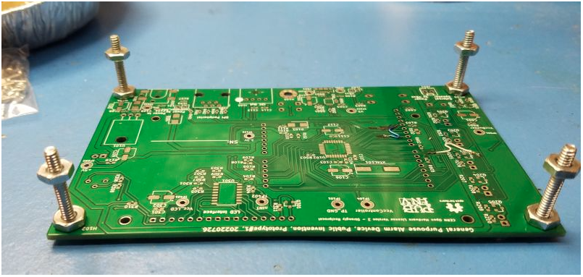
Also four 4.40 screws with washers and 4-40 nuts to make a 1/8" spacer for holding the LCD and header for soldering.

### Rework per issue #213, Remove R103
GPAD Rev 2.0 PCB, Remove the Resistor R103 (Loads the Peripheral Select), Update Factory Test for D601. #213
**Problem:**
The assemblies built per the BOM_JLCPCB_20230228Modified.xls have R103 fitted with a 1K resistor. This resistor with the LED D102 loads the SPI_CLK signal and is incompatible with proper operation of the GPAD as an SPI Peripheral from a 3.3V SPI Controller using the level shifting method using the common gate MOSFET.
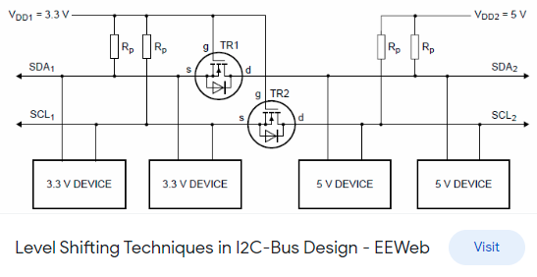
**Solution:**
Remove R103.

### Assembly Steps

1. LCD Bezel Grounding.
On the LCD module locate the J1 and J2 solder pads which if soldered ground the bezel.
View of J1 and J2.
Solder them.
Solder on of J1 and J2.
As soldered.
2. The 16 pin header is fit and soldered on to the LCD sub module. Then the pins are placed through the GPAD PCB. Four, nylon 1/8" spacers are placed at the four corners of the LCD sub module. Four 4-40 x 3/8" screws with 4-40 x 3/16" nuts go through both boards and are torqued to 3.4 - 4.8 Inch-Pounds. Solder the LCD header pins into the GPAD PCB.
TIP: Using the assembly fixture the 16 pin header can be held flush to the LCD module to solder a center pin to start the process.
Assembly Fixture View 2
View of holding header to LCD.
3. Put Reset button, S101 into PCB from display side.
4. Put Mute button, S401 into PCB from display side.
5. Put Buzzer, BZ601 into PCB from display side. Bending leads may help retain.
6. Put Contrast pot, RV301 into PCB from display side. Bending leads may help retain.
7. Through hole LEDs at locations D201-D205 and D105 with a stand-off spacer.
LEDs with spacers.
Thread the LED leads through the stand-offs. The longer LED lead is the anode. The cathode has a flat side on the plastic case.
Place the LEDs in to the PCB so that the flat cathode side corresponds to the silk screen marking. Bend the leads to retain the LED into the PCB. Placing the assembly on the fixture lets you have access to the top and the bottom of the assembly.
Assembly Fixture View with LEDs ready for soldering.
Life LED and reflow solder for a flush fit on the PCB.
For each LED, after soldering one lead, holding the LED from below up to the spacer and the PCB and reheat / reflow the solder for a flush fit.
Solder the second lead on the LED.
Trim the excess leads on RV301 and the LEDs.
> *Assembly Tip:* [Sharpie Oil-Based Paint Markers](https://www.sharpie.com/markers/chalk-paint-markers/sharpie-oil-based-paint-markers-fine-point/SAP_37371PP.html) can be used to mark polarity on LED standoffs and mark PCB's version, serial number and programming status of the microprocessor.

**Rejoice! Electrical assembly is done.**

LCD side components installed.

### Electrical Tests
Electrical tests are in two parts.
1. Unprogrammed measurements made before flash programming the boot loader and other firmware and...
2. Programmed measurements made after a boot loader and firmware have been placed into the microcontroller

#### Electrical Measurements before programming boot loader and firmware
Measure and record by serial number the following electrical parameters.
Investigate and correct abnormal measurements before applying power. Remove J102 and J103 and retain if present. Note where they should be replaced.
Start with no connections to the DUT (Device Under Test).

**Power Jack** Measure resistance to ground at J101 center pin as greater than **TBD** ohms.

**SPI Interface** Measure resistance to ground at J401 pin 5 as greater than **TBD** ohms.

**Vin net** Measure resistance to ground at TP102 as greater than **1 Meg** ohms. This net is capacitive and the resistance measured will climb as the meter charges the net.

**+5V net** Measure resistance to ground at TP103 +5 as greater than **TBD** ohms.

With a current limited supply set for 12V and maximum of **TBD** mA, apply power at J101 and note and record the unprogrammed current.
(FYI, when unprogrammed, the first time power up current is normally about **TBD** mA.)

Check that the power LED D105 is lit and is RED.

**+5V net** Measure the voltage of the +5V Net at TP103.

(FYI, a programmed DUT that has been powered up, and with display back light on, Hold the reset switch and measure current as about **61** mA)

**Vo Initial Set / LCD Contrast.**
With a volt meter, measure the voltage of the Vo pin of the LCD header to ground. Adjust RV103 for 1.3 V.
This is an initial guess. Later in the process will be the actual setting of the contrast.
See records of measurements of some of the Rev 2 assemblies at this issue: https://github.com/PubInv/general-alarm-device/issues/217 #217

**Electrical Test Results Table**

In Tennessee:
* All resistance measured on 20Meg scale except R@5V net measured on 2K scale. Multi meter EMCO Model DMR-3800 unless noted.
* All current measured 200mA scale. Multi meter EMCO Model DMR-3800 unless noted.

Capture:
DUT Serial Number, R@PowerJack, R@SPI Interface, R@Vin net, R@5V net, UnProgramCurrent, Volt@+5 TP103, FullCurrent mA, Vo Volts, Notes

DUT Serial Number | R@PowerJack | R@SPI Interface | R@Vin net | R@5V net | UnProgramCurrent | Volt@+5 TP103 | FullCurrent mA | Vo Volts | Notes

### Additional Measurements of current with in subcircuits Issue #230
See data from Rev2 build here: https://github.com/PubInv/general-alarm-device/issues/230

### Load Firmware
** Note: Loading firmware through the SPI interface is a manufacturing test of the SPI hardware components. **

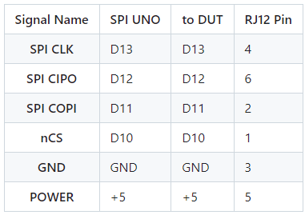
#### Load Bootloader
Use an Arduino UNO as an ISP (Incircuit Serial Programmer) which will load the boot loader into the DUT.
Cable Connect the ISP UNO to the DUT as follows:

Wiring of the UNO to the DUT.
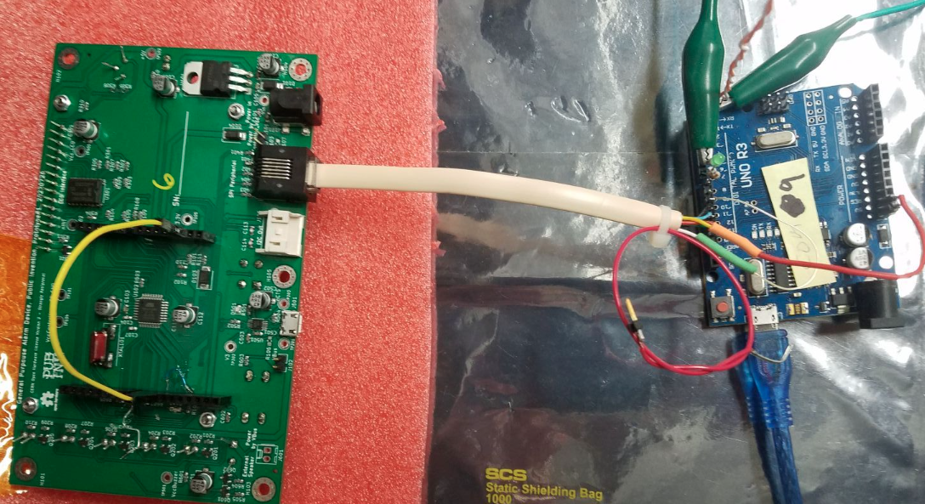
Place a Jumper on the DUT from D10 to Reset

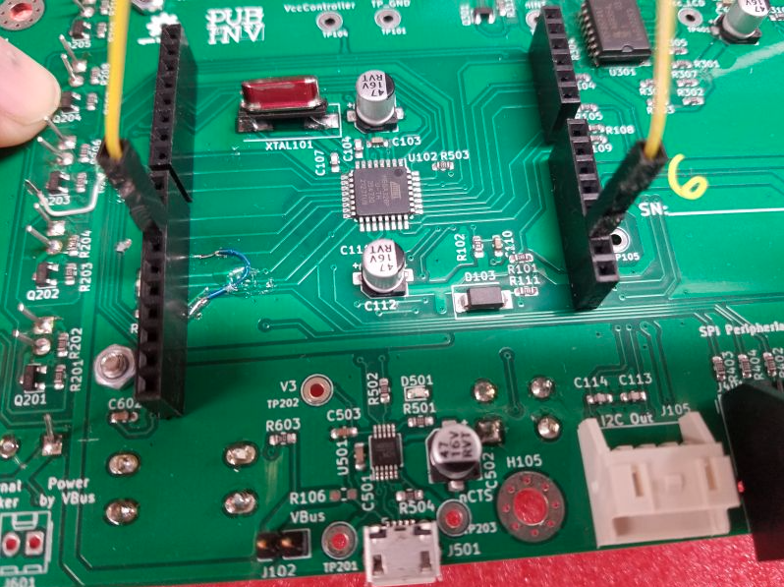
##### Missing Jumper to D10 When Load Bootloader
If you forget the above jumper the IDE will give an error something like this:
>Arduino: 1.8.19 (Windows 10), Board: "Arduino Duemilanove or Diecimila, ATmega328P"
>avrdude: Yikes! Invalid device signature.
> Double check connections and try again, or use -F to override
> this check.
>Error while attempting burning of bootloader with out the RJ12 connection.
>This report would have more information with "Show verbose output during compilation" option enabled in File -> Preferences.

Load into the IDE the sketch "ArduinoISP".

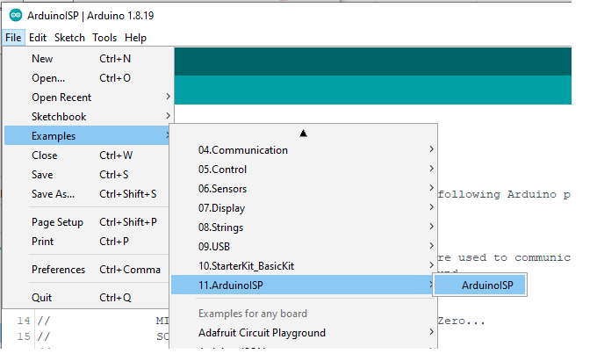

To load into the UNO, Select the serial port for the UNO and compile and upload with the "ArduinoISP" by pressing **<Ctrl>U**.

Setup the UNO to burn the boot loader into the GPAD target.
Select the board type (Boot loader type) to "Arduino Duemilanove..." .

Select the Processor type to "ATmega328P" .

Select the programmer type.
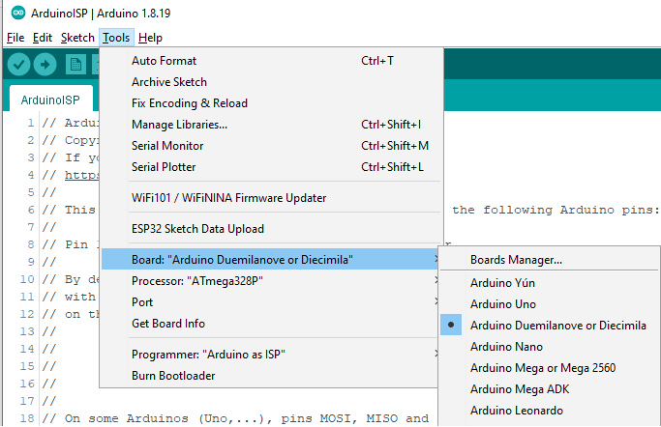

In the Arduino IDE, select TOOLS > Burn Bootloader .
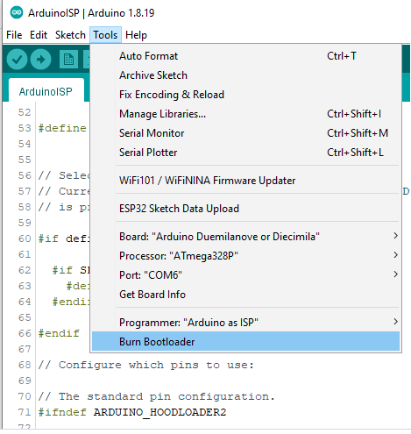

Watch the progress bar in the IDE and look for success with the message "Done burning bootloader." in the blue status bar.

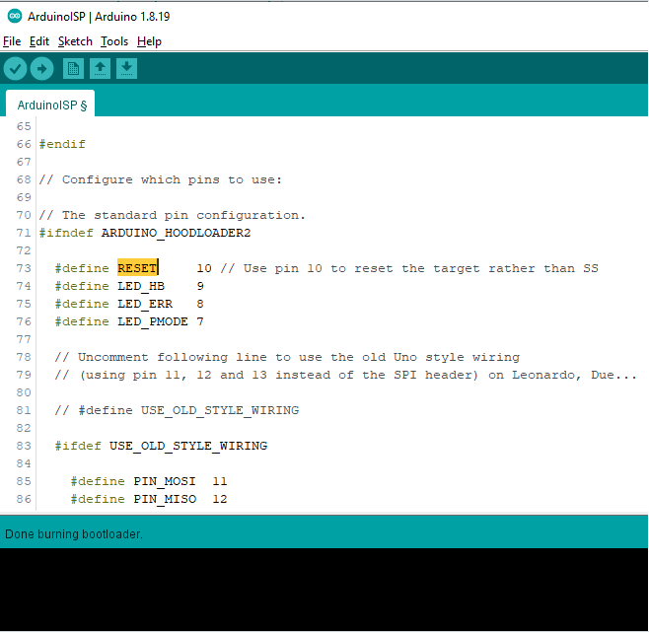
IF R103 has not been removed, check that LED D102 is winking with a short on time and longer off time indicating that the boot loader has been loaded. Until any other sketch is loaded this is the expected behaviour of the unit under test.

#### Load Factory Test Firmware.
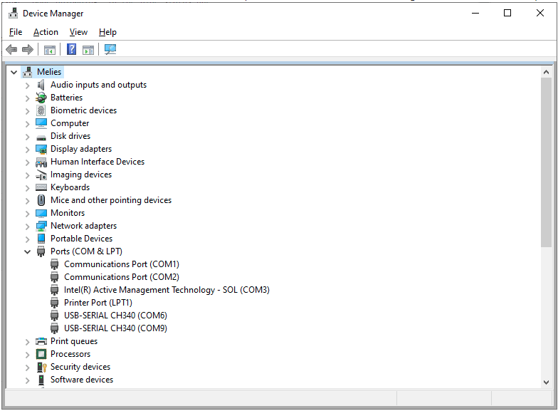
Connect a USB cable to the DUT. Note the COM port enumerated in Device Manager Ports(COM&LPT) drop down

In the Arduino IDE, open the new file "GPAD_Factory_Test.ino".
Set the IDE for the COM port of the DUT.
Using the Arduino IDE, compile and upload to the DUT the "GPAD_Factory_Test.ino"
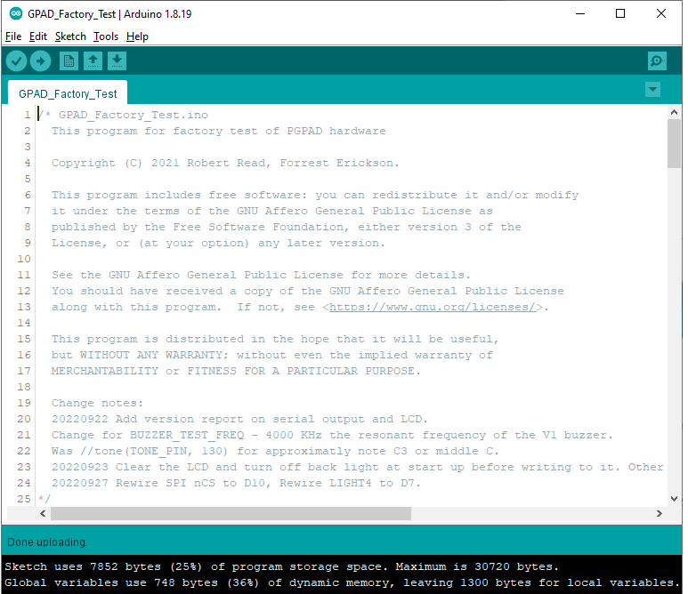
Watch the progress bar in the IDE and look for success with the message "Done uploading" in the blue status bar.

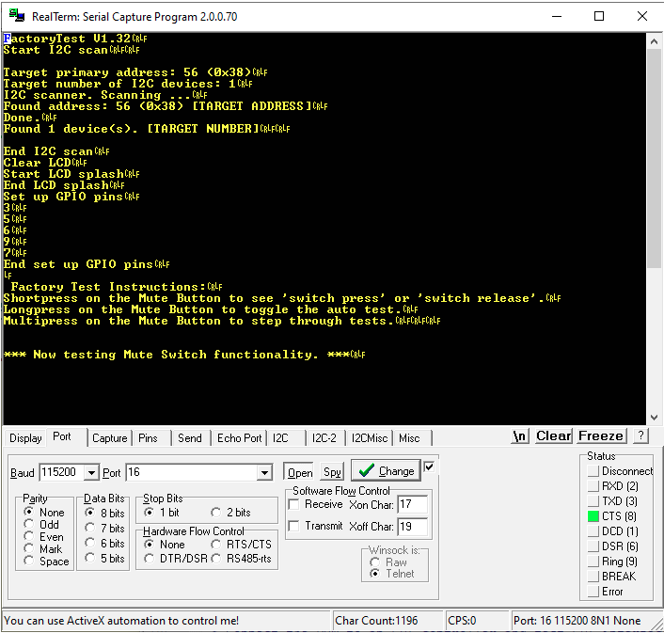
Open a terminal to the COM port of the DUT and set for appropriate BAUD rate.
Press the reset switch on the DUT and the LCD should display a message. The terminal should display a boot message too. This example is of a RealTerminal connected to the DUT.

#### Electrical Measurements After programming bootloader and firmware
Measure and record by serial number the following electrical parameters.

Observe the current on the DUT. Press the Mute Switch S601 and the white LEDs D201-D205 should light. The Buzzer will make a sound. Record this full current in the table above.

# End of Rev2 Tests as of March 2023

- Operation instructions
Provide detailed, step-by-step instructions for the safe and proper operation of the hardware.
- Use visual instructions, as necessary.
- Highlight any potential safety hazards.

A video demonstrating [3] one use of the GPAD (via the serial port) shows not only the usage but also shows the flashing lights and allows you to listen to the audio of escalating urgency.

The GPAD is activated by sending it digital commands over a cable from a different microcontroller. The basic use case is that a condition which needs human attention is detected in whatever manner possible by a sensing microcontroller or computer, called the controller. For example, the sensing device might detect that a temperature is too high, or that a the total flow through an airway in one minute is too low. It than calculates which of five alert levels (not counting the “no alert” condition, which could be considered a sixth) represents the severity of the condition, and a message of up to 80 characters that will inform a person how to remedy the problem. This message is displayed on the back-lit LCD on the GPAD itself. The LCD is dark when the alarm level is silent and back-lit in the other alarm levels.

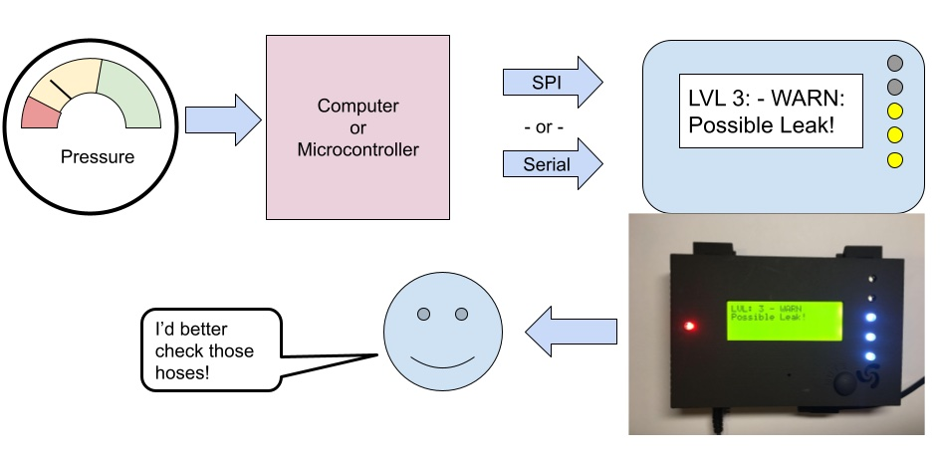

Conceptually, the sensing device treats the GPAD as an API—an Application Programmers Interface. The six alarm levels are conceptually named:
- Silent,
- Informational,
- Problem,
- Warning,
- Critical,
- Panic.

The exact meaning of the six levels can be defined by the user for the application. Of course, not all six have to be used. However, the affect of the device should be clear: increasing severity leads to increasing sound and light levels produced by the device to obtain the attention of a human being. The GPAD has 5 LEDs, which are normally unlit in the Silent mode. Each increase in alarm level increases the number of LEDs lit. Our intention is that even from across a room a user may comprehend the alarm level at a glance.

Similarly, at increasing urgency levels, the GPAD plays a different rhythmic pattern of high-pitches sirens, which could be described as a “squeal” or a “scream”. This sound currently gets more urgent-sounding in terms of speed, rhythm, and frequency alternation as alarm level increases. Of course, the user is free to change or improve the coding of the GPAD itself, and a programmer will easily see where we implement the “songs”.

In order to actually send the message, the programmer of the sensing device will likely use our software library. A C/C++ programmer will likely immediately understand the API from its actual declaration in the file alarm_api.h:

#ifndef ALARM_API
#define ALARM_API
#include <Stream.h>

enum AlarmLevel { silent, informational, problem, warning, critical, panic };
// const char *AlarmNames[] = { "OK ","INFO.","PROB.","WARN ","CRIT.","PANIC" };
const int NUM_LEVELS = 6;

const int MAX_MSG_LEN = 80;
const int MAX_BUFFER_SIZE = MAX_MSG_LEN + 1;
typedef struct {
uint8_t lvl;
// we will use a null-terminated string!
char msg[MAX_MSG_LEN+1];
} AlarmEvent;

int alarm_event(AlarmEvent& event,Stream &serialport);
int alarm(AlarmLevel level,char *str,Stream &serialport);

#endif

The API has two entry points: alarm and alarm_event. The function alarm is simply a convenience function for calling AlarmEvent which constructs an AlarmEvent for the programmer. An AlarmEvent, as stated above, consists of an AlarmLevel and an 80-character (null-terminated) character array holding the message to be displayed on the LCD.

Hardware Connection
Schematics in PDF form can be found in the folder at:
https://github.com/PubInv/general-purpose-alarm-device/tree/main/Hardware/GeneralPurposeAlarmDevicePCB/PDF
You can View Schematics on Line with the links at: https://github.com/PubInv/general-purpose-alarm-device/tree/main/Hardware/GeneralPurposeAlarmDevicePCB
The GPAD requires a 12V power supply via a standard 5.5mm OD 2.1mm pin. It draws less that 1000 mA, even at the highest alarm level.
The GPAD exposes an SPI interface through an RJ12 jack. The SPI pins are mapped the the RJ12 jack as:
SPI Peripheral Pins
The connector is JR12 6P6C and pin 1 is on the left then the connector is held with the contact pins up and facing the observer.
Note the GPAD is a 5V logic level peripheral device. Level shifters must be used when controlled by a 3.3V device.
Pin# | Signal Name | Note
1 | nCS | Active low
2 | COPI | Input to GPAD
3 | GND
4 | SCK | Input to GPAD
5 | ControllerVcc | 5 Volts, an optional way to put power into the GPAD
6 | CIPO | Output from GPAD, 5V.

Muting

The GPAD has a mute button. The button silences the sound but does not change the LED lighting. The GPAD stores an internal state as muted or not. The mute state is not accessible to the controlling device.

Example Controller Devices

General-purpose Computers

In order to develop and test the GPAD the functioning of the GPAD, it can be driven easily by a serial interface from a laptop computer by simply using a serial monitor. We have designed a trivial interface of commands that the GPAD listens for on the serial interface. Each command begins with one of 4 characters and is terminated by a newline. These are:
- “a” is the most important command, and is used to set the alarm level. The “a” command is of the “aN”, where N is one of {0,1,2,3,4,5}, specifying increasing alarm levels respectively. These two characters are followed by up to 80 characters defining a message, terminated by an end-of-line (eoln) character.
- “h” prints a helpful message.
- “s” means “silence” – mute the GPAD.
- “u” means “unsilence” or “unmute” – the GPAD is allowed to make noise.

The easiest way to send these serial commands is with a terminal program, or the “serial monitor” feature of the Arduino IDE, which is useful for testing. However, to actually program the GPAD to alert to a recondition, a library such as PySerial that allows a message to be transmitted over the serial port from general purpose programming language.

Microcontrollers
However, an important use case for the GPAD to be programmed by another microcontroller. The SPI interface is particularly useful for controlling a GPAD from another Arduino-class microcontroller. In fact, to make testing as easy as possible, we have software that allows a GPAD peripheral to be programmed by another GPAD acting as a controller. This can be found in the directory GPAD_API_SPI_CONTROLLER (https://github.com/PubInv/general-purpose-alarm-device/tree/main/Firmware/GPAD_API_SPI_CONTROLLER). This code is a useful starting point for anyone programming a GPAD for any given use case, because it exercises the SPI interface and in particular the GPAD Application Programmers Interface.

- Validation and characterization
Demonstrate the operation of the hardware and characterize its performance for a specific scientific application.
- Highlight a relevant use case.
- If possible, characterize performance of the hardware over operational parameters.
- Create a bulleted list describing the capabilities (and limitations) of the hardware. For example, load and operation time, spin speed, coefficient of variation, accuracy, precision, etc.

The GPAD is designed to be a part of the Freepsireco ecosystem [2] and serve as the medical alarm in an ICU ward for the PolyVent open-source ventilator. Specifically, it is designed to alert clinicians to conditions which can be electronically computed by the PolyVent microccontroller. These include (but have not yet been coded):
- A hose disconnect to the patient
- A loss of pressure
- Patient-ventilator asynchrony
- In ability to achieve programmed Peak Inspiratory Pressure, etc.
The GPAD has been demoed in public quite a bit. It reaches a loudness of TODO. The LEDs are fairly bright. The basic electrical performance of this simple device seems clear.

However, the true value of an alarm device can only be measured its ability to draw human attention, and then to inform a human being how to take action, and then not to distract them further. There are both simple and complex human/machine interaction performance metrics which we have not begun to measure for the GPAD. A good introduction to the complexity of this field can found in Konkani, Oakley and Bauld (2012).[1]

In the language of the field, the GPAD is not yet a “smart alarm”, an “alarm management system”. It is rather, an annunciation device. (If we called it that, however, non-experts would not understand its intended use.) We hope researchers in this area will find the GPAD a useful programmable component for such such systems and tool for such investigations.

CRediT author statement

Robert L. Read: Conceptualization, Software, Funding Acquisition, Writing – Original Draft.
Lawrence Kincheloe: Supervision, Methodology.
(Forrest) Lee Erickson: Software, Validation.
Oluseyi 'Seyi' Adeniyi: Software

Lawrence Kincheloe designed the enclosure and mentored the OU capstone projects.
Lee Erickson performed schematic capture designed the PCBs, wrote the assembly instructions and captured measurements on units during assembly and during some troubleshooting. Lee wrote initial factory test firmware and the factory test procedure which applies the firmware.
Oluseyi 'Seyi' Adeniyi expanded the factory test firmware to include “walking one” like tests for more through tests against shorts and bad LCD displays. Seyi also designed the alarm sounds.

Please add a CRediT author statement for your data article here, using thepage. categories listed on this web

Acknowledgments

We would like to thank two senior capstone engineering classes at the University of Oklahoma who made potential extensions to the GPAD. Although they have not yet been used in this project, they have clarified our thinking for future enhancements.

Funding: This work was supported by Public Invention, Austin, TX, a US 501c3 public charity.

References
If relevant, you should include a reference to the original publication of the hardware you customized and a reference to the repository in which your design files are published. Other references can be included, as required; for example, references that put your device in context in the literature. For more information on the reference format in HardwareX please see the Guide for Authors.

[1] A. Konkani, B. Oakley, T. J. Bauld, Reducing hospital noise: a review of medical device alarm management. Biomedical Instrumentation & Technology, 46(6) (2012), 478-487. https://array.aami.org/doi/full/10.2345/0899-8205-46.6.478

[2] R. Read, The Freespireco Project: A complete, free-libre open-source, easily repairable, widely usable, safe and effective respiratory support medical device ecosystem. (2023) https://github.com/PubInv/freespireco.

[3] R. Read, Demo of GPAD Light and Sound. https://youtu.be/F5cf5-Cmwu0. Accessed July 10th, 2023.

[4] Mucco Test Horn literature. https://muccosignal.com/product/warning-horns-with-16-tons/
______________________________________________________________________
Additional Information for authors. (do not include these lines in your submission)
Author manuscript checklist
- Is the subject of the submission under an open source license? Are design files in the preferred format for making modifications as defined by the Open Source Hardware definition?

- Can the hardware be reproduced with the details provided in the submission?

- Are all relevant design files available on either the Mendeley Data, Open Science Framework, or Zenodo repository? Are they described in the Design Files Summary, and clearly documented? (E.g., descriptive file names, commented code, labeled images, etc.)
  - If in the Open Science Framework, has the repository been registered? Instructions
  - If in Zenodo, is the repository open access and published? Instructions
  - If in Mendeley Data, is the repository published or the sharable link included in the additional information you plan to submit? Instructions

- Are visual instructions used when necessary?

- Is the utility of the hardware to the scientific community explained clearly? Has a specific scientific application been demonstrated using the hardware?

- Is the performance of the hardware adequately demonstrated and characterized?

- Are all potential safety concerns addressed?

- For more information on the article template consult the Guide to Authors.

Reminder: Before you submit, please delete all
the instructions in this document (the text in italics), including this paragraph.
Thank you!

